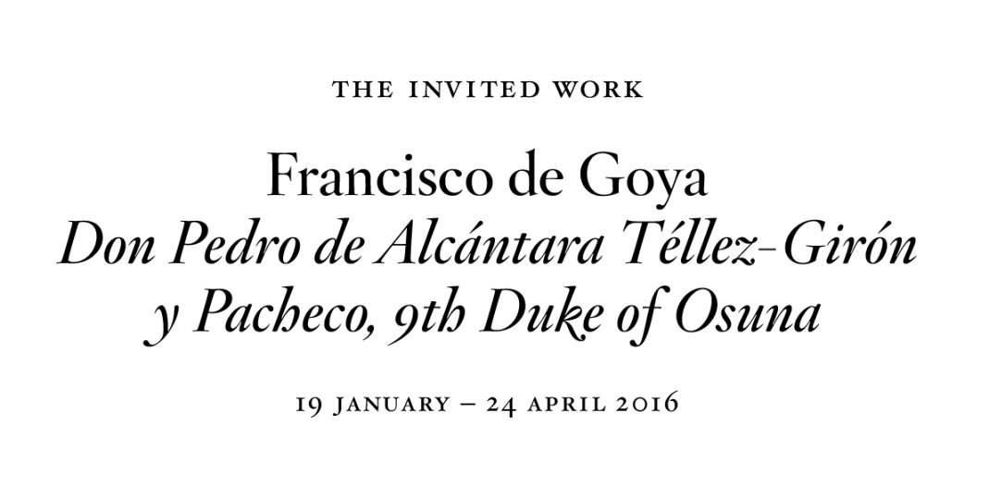

For a period of three months, Room 34 of the Prado’s Villanueva Building will be displaying Goya’s portrait of Don Pedro de Alcántara Téllez-Girón y Pacheco, 9th Duke of Osuna, one of the most interesting works by the artist among those housed in the Frick Collection in New York.

The special loan of this work falls within the context of the Museum’s “Invited Work” programme, an activity sponsored by the Fundación Amigos del Museo del Prado since 2010 with the aim of further enriching a visit to the Museum and establishing points of comparison that allow for a reflection on the works in the Prado’s Permanent Collection.

Madrid, 18 January 2016. The Museo del Prado and the Fundación Amigos del Museo del Prado are presenting Goya’s portrait of Don Pedro de Alcántara Téllez-Girón y Pacheco, 9th Duke of Osuna. Through the collaboration of the Frick Collection in New York, where it is normally housed, the painting will be on display in Room 34 of the Villanueva Building until 24 April this year.

Traditionally dated to around 1798, the recent cleaning of the portrait at the Metropolitan Museum in New York has revealed a complexity of technique and use of colour that may allow it to be dated later, possibly even to after the Duke’s death in 1807.

While the sitter’s clothing corresponds to the late 1790s, the dark tonality and manner of painting the dress coat and hands are closer to Goya’s technique during the period of the Peninsular War. This hypothesis is supported by the fact that the work does not appear in the records of the Osuna residence in which purchases made in the 18th century are rigorously recorded, but it does however appear in the sale of the Osuna collection in 1896. It is also possible that this is the portrait referred to in an inventory of the collection of around 1834 as an oil painting “of half-length of the Duke of Osuna, grandfather”.

This information seems to indicate that the portrait was commissioned during a turbulent period, possibly at the time when the Osuna family moved to Cadiz after the Duke’s death and prior to the French invasion.

In Goya’s image the Duke transmits the sensitive, enthusiastic personality that made him a popular figure among intellectuals of the time. The dimensions of the work, which are similar to those of the portrait of the Duchess of 1786 (Marita March collection), the Duke’s pose and the direction of his gaze all suggest that Goya probably painted it from a miniature and that it was used as a pair to the portrait of the Duchess.

Don Pedro de Alcántara Téllez-Girón y Pacheco, 9th Duke of Osuna (1755-1807) was one of Goya’s earliest and most eminent patrons from the mid-1780s onwards. After his death the artist continued to work for his wife and children until 1817. The Prado has various works painted by Goya for the Osunas, including the group portrait of the entire family of 1785, those of the Marchioness of Santa Cruz (1805) and the Duchess of Abrantes (1816), and the unique Witches’ Flight, one of the “scenes of witches” from the series that Goya sold to the Duke in 1798.

The Frick Collection
The Frick Collection is one of New York’s most outstanding museums, housing works that are among the most important by the artists represented in its collection. Assembled over the course of his lifetime by Henry Clay Frick (1849-1919), a Pennsylvania steel magnate, with the idea that after his death and that of his wife Adelaide Howard Childs (1859-1931) the collection would pass into public ownership, from 1914 it occupied the mansion on Fifth Avenue in New York designed for the couple by the architect Thomas Hastings. This grandiose building was conceived to house the collection of paintings, sculptures and examples of the decorative arts that Frick had acquired, to which further works were added after 1931.

Fundación Amigos del Museo del Prado
This institution is the Prado’s oldest and most committed benefactor. Since its foundation in 1980 it has undertaken a wide-ranging activity of sponsorship, in addition to contributing to the dissemination knowledge of the Prado’s collections and to supporting research on those collections through courses, exhibitions and publications. The Fundación currently has 29,000 Friends. More information at: www.amigosmuseoprado.org

